Hi team,

Attached are my updates across global markets over the long weekend. I hope this is useful, and please feel free to let me know if there is anything I should adjust or improve going forward.

Thank you for taking the time to read it, and I am looking forward to being back on the desk tomorrow.

Best,
Jian

—————————————————
22 Jun Weekend Updates:

US:
- US initial jobless claims came in 226k last week, slightly above consensus of 225k.
- The USDX continued to grind higher, breaking above the 101 handle and reaching its highest level since May 2025.
Comment: USD rates likely remain current level. Resilient claims and USD strength keep the Fed away from a dovish pivot, but I question the market’s aggressive pricing of 1–2 hikes this year. The bar for both cuts and hikes looks similarly high: growth is not weak enough for cuts, while inflation has not yet broadened enough to force immediate hikes. I would therefore favor a back-loaded hiking path. (SFRZ6Z7 Steepener recommended, current level -14bps, TP 25bps, SL -25bps, to express the back-load hiking path view)

JP:
- Yen weakened to a near two-year low, with USDJPY trading above 161 for the first time since July 2024.
- Japan Finance Minister Katayama said authorities stand ready to take decisive action against speculative moves in the FX market.
- BoJ Deputy Governor Ryozo Himino said the BoJ will continue to raise rates further, even if price increases are initially driven by supply shocks, the BoJ would need to consider policy action if they lead to broader price increases and feed into underlying inflation.
Comment: JPY rates front-end hawkish, as USDJPY above 161 is testing Japan’s pain threshold near 162. Beyond FX intervention risk, further yen weakness keeps imported inflation pressure alive and supports faster BoJ hike pricing. Market was paying JPY front-end into the move last Friday to express higher BoJ reaction-function risk.

AU:
- Australia extends fuel excise relief to ease household cost pressures, as the country continues to grapple with higher fuel costs during the Iran war. But the 32 cents per litre cut will drop to 16 cents per litre.
Comment: Front-end slightly dovish, as the fuel excise relief reduces near-term headline CPI upside risk. However, with inflation still sticky and the RBA keeping further tightening on the table, markets are unlikely to move aggressively into cuts; hike risk remains priced, with ASX implying around 28% odds of a move to 4.60% at the next meeting.

EU:
- ECB’s Escrivá: Higher energy costs are being passed through to other goods and services, including services, transportation, and food, which are experiencing significant price increases. However, the second-round effects from wages have not yet materialized.
- ECB’s Lane: ECB will take whatever action is necessary, just as the Fed would. Euro-area inflation is likely to remain above target for an extended period, while the upper end of the ECB’s neutral-rate range has risen to 2.50%.
Comment: Hawkish speak from ECB speakers, continuing to push back against any quick dovish pivot. Expect pricing "higher for longer”, with lack of clear wage second-round effects.

Iran Conflict:
- Iran announced new transit rules for the Strait of Hormuz, requiring vessels to submit applications 48 hours in advance. Saturday night, IRCG announced the close of Strait of Hormuz. Over the weekend there have been no visible records of vessel passage.
- Israel officials pushed back hard against Vance’s remarks, saying: “Do not threaten us. Traitors will pay the price.”
- Starting from Sunday, Iran, US, Pakistan, Qatar have all arrived in Switzerland. The focus would be ceasefire in Lebanon and nuclear issue. By Sunday night, Vance: "Significant progress has been made over the past few hours, US and Iran now envision a shared future where all parties can work together."
Comment: Shift to neutral view on MOU outlook. Overall direction appears more constructive, the key positive shift is that Netanyahu first-time reportedly instructed Israel to halt attacks on Lebanon. With the Trump administration motivated to secure progress ahead of the mid-term cycle, near-term volatility should persist, but negotiations now look to be moving in a more positive direction.

Hi team,

Attached is my preview for the week ahead. I hope this is helpful, and please feel free to let me know if you have any questions, feedback, or suggestions on how I can make it more useful.

Thank you for taking the time to read it, and I am looking forward to being back on the desk tomorrow.

Best regards,
Jian

—————————————————
US key focus this week:
- Tue 23 Jun, 9:45pm HKT, Manufacturing & Services PMI
- Wed 24 Jun, 1:00am HKT, 2Y Note Auction
- Wed 24 Jun, 11:30pm HKT, 2Y FRN Auction
- Thu 25 Jun, 1:00am HKT, 5Y Note Auction
- Thu 25 Jun, 8:30pm HKT, PCE & Final GDP & Unemployment Claims
- Fri 26 Jun, 1:00am HKT, 7Y Note Auction

Japan key focus this week:
- Tue 23 Jun, 5Y JGB Auction
- Wed 24 Jun, 2:40pm HKT, BoJ Ueda Speaks (Himino to read on behalf)
- Thu 25 Jun, 20Y JGB Auction
- Fri 26 Jun, 7:30am HKT, Jun Tokyo CPI

Australia key focus this week:
- Tue 23 Jun, 9am HKT, 10Y ACGB Auction
- Wed 24 Jun, 9:30am HKT, CPI
- Wed 24 Jun, 2:30pm HKT, RBA Deputy Gov Hauser Speaks
- Thu 25 Jun, 9:30 am HKT, Labor Force Survey

US:

May PCE:
Thu 25 Jun, 8:30pm HKT
- Headline PCE: BBG consensus +0.5%mom, +4.1%yoy, last month: +0.4%mom, 3.8%yoy
- Core PCE: BBG consensus +0.3%mom, +3.4%yoy, last month: +0.2%mom, +3.3%yoy

The market tends to have a relatively accurate prediction on PCE, as economists can map a large share of the PCE basket from already-released CPI, PPI, and import price data. As a result, the main uncertainty is less about the headline direction and more about specific components.

Key Components we may pay attention:
- As Warsh just mentioned in FOMC press conference, Fed would look more at AI-related supply-side effect, we could look at components related to AI Capex. Hardware: Personal computers, Telephone and related communication equipment, Cellular telephone service. Software: Software and accessories.
- Second-round inflation pressure: Air transportation; Motor vehicle services; Food services; Housing.

Japan:

BoJ Ueda Speak (read by Himino):
Wed 24 Jun, 2:40pm HKT
This speak is conducted every year and short, the content would be a simple explanation of the decision at the Jun BoJ policy meeting and views on the economy & inflation. Expect to keep the press conference stance, which is downside risks to the economy have decreased, while the risk of inflation exceeding 2% still. Market now is pricing Dec 25bps hike.

Jun Tokyo CPI:
Fri 26 Jun, 7:30am HKT
- Core CPI (ex-fresh food): BBG consensus: +1.6% yoy, last month: +1.3% yoy
- New-core CPI (ex-fresh food & energy): BBG consensus: +1.8% yoy, last month +1.6% yoy

As per last week’s BoJ policy meeting, BoJ flagged that: "However, the price pass-through stemming from the rise in crude oil prices has been progressing at a relatively fast pace in business-to-business transactions, which could spread to an increase in consumer prices across a wide range of items.”, suggesting their worry regarding second-round inflation.

Australia:

Australia May CPI:
Wed 24 Jun, 9:30am HKT
- Headline CPI: BBG consensus: +4.3% yoy, last month: +0.4%mom, +4.2%yoy
- Trimmed mean CPI: BBG consensus: +3.5% yoy, last month: +0.3%mom, +3.4%yoy

April headline CPI increased 0.4% mom, 4.2% yoy which dropped 50bp from March. The declines on automative fuel offset travel price hike.

On May CPI, as the auto fuel continues to go lower, driven by lower global crude oil prices, tax reduction, and public transport subsidies, suggests headline inflation faces greater downside risk than usual. Beyond the headline downside risk, we also need to watch whether second-round inflation pressure materialize as any evidence of broader pass-through would matter for the RBA’s reaction function given its persistent sensitivity to inflation risks. (Stuffs to look at: Airfares, Food services, New dwelling purchase)

Average weekly prices for Australia automative fuel.

Source: Australian Institute of Petroleum

Australia May Labor Force Survey:
Thu 25 Jun, 9:30am HKT
- Total Employment: BBG consensus: +32.5k, last month -18.6k
- Unemployment rate: BBG consensus: 4.4%, last month 4.5%
- Participation rate: BBG consensus: 66.7%, last month 66.7%

The UE had a upside surprise in April, up 0.2% to 4.5%, while the decline of employment was driven by a decrease in both full-time and part-time employment. Although softer labor demand is broadly consistent with the recent tightening in financial conditions, the weakness looks sharper than expected.

Notably, April report: 1) Is the first release following the ABS’s full transition to a more modern data collection methodology, the new process may be adding some noise to the data. 2) May be partially impacted by the Easter holidays, this year the Easter holidays completely overlap the survey period.

The historical pattern for Easter overlap suggests that the unemployment rate either stabilized or declined in May after a softer April outcome.
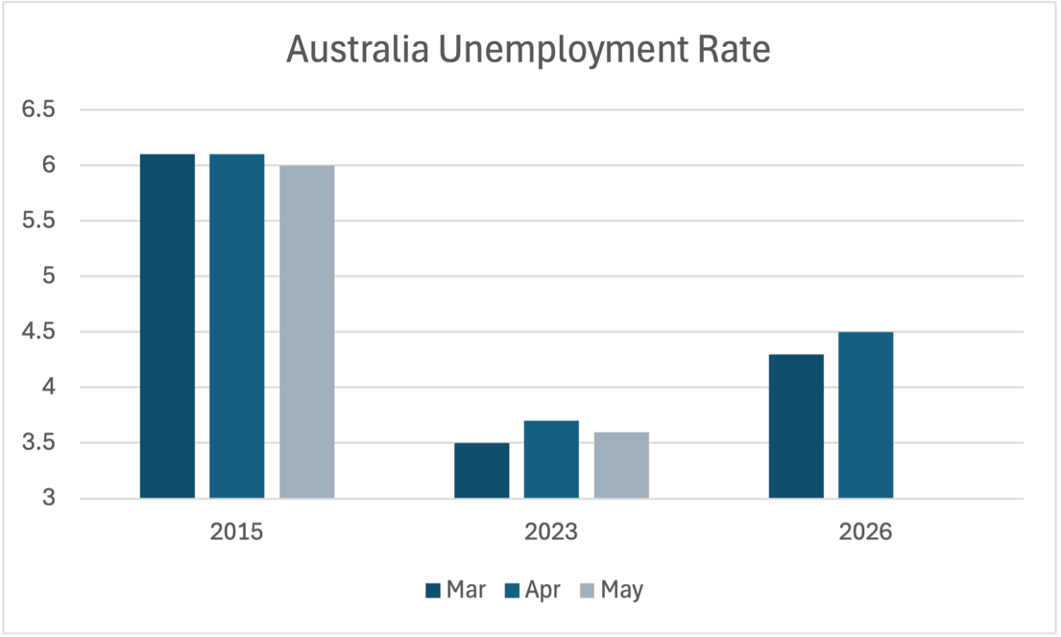

Source: https://www.abs.gov.au/statistics/labour/employment-and-unemployment/labour-force-australia

Considering all headwinds for April labor force survey, and alternative data like ANZ-indeed Australian job ads suggests May labor force survey would rebound, UE should stabilized or declined at 4.4% or 4.3%.
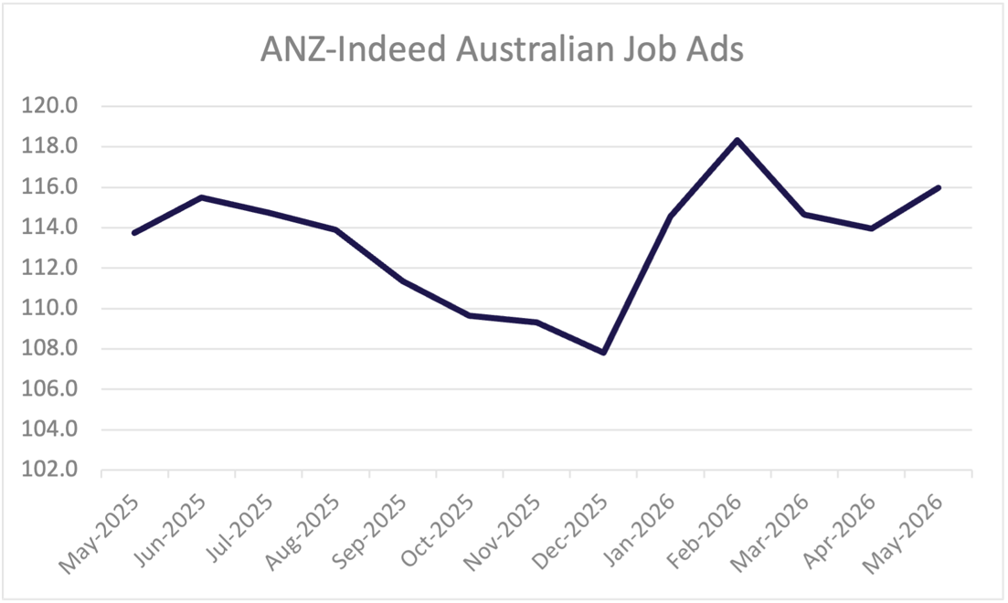
Source: https://www.anz.com.au/newsroom/media/release-dates/

